

**TITLE**

*Brain Computer Interface can Translate Thought into Speech*

Name : Muhammad Harith Bin Zainudin

Matric : 192171

Course Code : SSE3306

Course Name : Human Computer Interface

Lecturer Name : Dr. Azrina Binti Kamaruddin

Based on : https://www.inverse.com/article/52812-brain-computer-interface-translates-thoughts-to-speech

We want to take human computer interaction into another whole new level by not just provide the interface that the user will interact like touch or push, but the computer itself will act as an interface and interpret what is in the brain. Yes, brain computer interaction. It is an interaction that the computer will interpret and extract the data that is in the brain itself rather than the user need to type for their message or WhatsApp or anything. But then this technology is still in its infant. It is still new and need more time to develop this type of technology.

According to a study, a system that can translate simple thoughts into speech is being develop and is currently under research by using artificial intelligence and a speech synthesizer. This system will translate brain activity into words. For example, a text message that is being translate just by using smartphone.

An associate professor at Columbia University, Dr. Nima Mesgarani tells that, he sees a great potential of this system to help people that cannot speak. Like people who have stroke, or living with amyotrophic lateral sclerosis (ALS). If you do not know what is ALS, it is a disease motor neurone that Stephen Hawking had. They cannot talk or speak. This system, will make a new achievement for mankind that open up doors for brain-connected smartphones. It will let the users text using their minds, although that is still a ways away. This is an alternative to human computer interaction that such a possible interaction between user and smartphone exist.

However, this idea is still far away because of the technique that they use to extract the data from the brain activity is by using non-invasive method. They have a brain surgery that put an electrode that can read the pulse that is in the brain. So, Dr Nima and his colleague, began their research by examining the brain activity of epilepsy patients. All these patients already had electrode implants in their brains to monitor seizures. They asked willing participants to listen what the speakers recite from numbers zero to nine, and after that, they will record the brain signals from that interaction. This brain signals will be recognize and will be translate into robotic sounding words using vocoder, a speech synthesizer.

Dr Mesgarani says that “It may take a decade before this technology becomes available, we need more progress both in long-term, bio-compatible implantable electrodes and/or breakthrough technologies in non-invasive neural recording methods. We also need a better understanding of how the brain represents speech, so that we can refine our decoding methods.”

This research only translate simple thought into speech, but our brain is capable of producing one terabyte per second. That is about 40 HD movies streaming in our brain every second. So, the problem is how we want to get all that information out of our brain and decode it. We still have a long ways to go.

All the willing participants had brain surgery already that have an electrode implants in their brain. This is extremely invasive method that requires to have a brain surgery. Most people might not be willing to undergo this process. As for now, this study only introduced a method that decode the brain activity into speech. If we figure out accurately how to translate simple thought into speech without surgery, we will be one step closer toward bringing about brain connected smartphone.

I think, in 5 to 10 years time, this project will be a focus for everybody as it will give many benefits to mankind. It will be a huge achievement for mankind if this project success as it will help person who cannot speak or talk properly can ‘communicate’ again.

The process that I have done to find this article is I search it using Google. I use the news tabs in google so that I can know the latest news that is trending in our world right now, and what is been a topic that is been focusing nowadays.

**ARTICLE**

Neuroengineers have created a new system that can translate simple thoughts into recognizable speech, using artificial intelligence and a speech synthesizer, according to a study published Tuesday.

A team of New York-based researchers was able to reconstruct words using only brain activity, an innovation that could pave the way for brain-controlled technologies like, say, a smartphone that can translate your thoughts into text messages.

Dr. Nima Mesgarani, an associate professor at Columbia University, led the study and tells Inverse that he sees great potential to help restore speech to people recovering from a stroke or living with amyotrophic lateral sclerosis (ALS). Further down the line, this type of tech could also open up doors to brain-connected smartphones that could let users text using their minds, though that’s still a ways away. His work was published in the journal Scientific Reports.

“One of the motivations of this work…is for alternative human-computer interaction methods, such as a possible interface between a user and a smartphone,” he says. “However, that is still far from reality, and at the moment, the information that can be extracted using non-invasive methods is not good enough for a speech brain-computer interface application.”

A representation of former Grateful Dead drummer Mickey Hart’s brain created by researchers at the University of California in a separate study.

Listen to the speech generated by the brain-computer interface.

To develop the new technique, Mesgarani and his colleague, Dr. Ashesh Dinesh Mehta from the Northwell Health Physician Partners Neuroscience Institute, began by examining the brain activity of epilepsy patients for their study. These patients already had electrode implants in their brains to monitor seizures, which Mesgarani and Mehta were able to use to gather data for their research.

The duo asked willing participants to listen to speakers recite the numbers between zero and nine, and then recorded the brain signals from that interaction. Next, they trained a neural network — a program that imitates neuron structure in the human brain — to recognize patterns in the signals and translate them into robotic-sounding words using a speech synthesizer, known as a vocoder.

The result was a short voice clip of what sounds like Microsoft Sam counting from zero to nine. The impressive part is just how clear the speech is compared to other methods the researchers tested. There’s still a lot of work to be done, though.

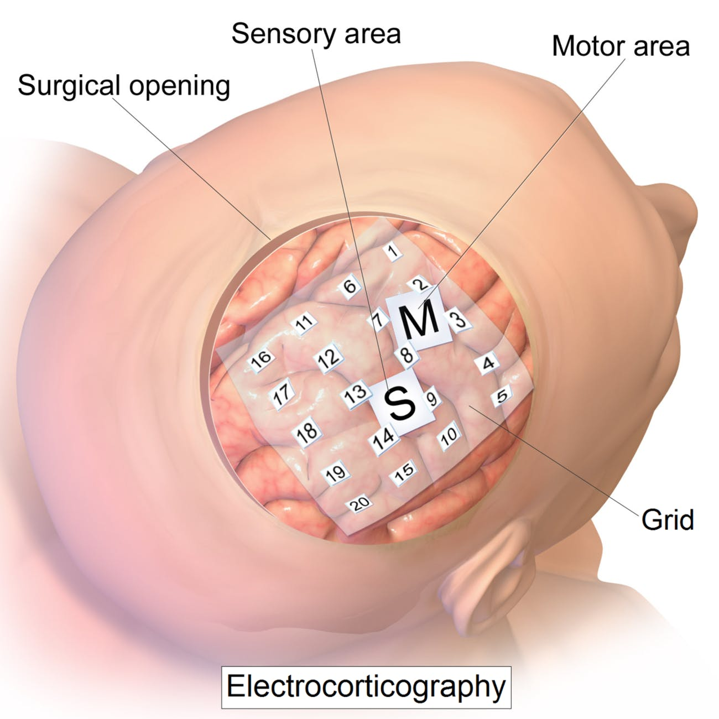

The type of surgically placed implant that the patients of this study had.It may take a decade before this technology becomes available.”

“It may take a decade before this technology becomes available,” says Mesgarani. “We need more progress both in long-term, bio-compatible implantable electrodes and/or breakthrough technologies in non-invasive neural recording methods. We also need a better understanding of how the brain represents speech, so that we can refine our decoding methods.”

The patients who were a part of this study, for example, all had brain surgery to implant electrocorticography monitors. This is an extremely invasive process that requires open brain surgery, something that most people might not be willing to undergo, even if there was a possibility of restoring some of their speech capabilities.

For now, this study introduced a method for decoding brain signals into speech. If we figure out how to accurately detect brain activity without surgery, we’ll be one step closer to not only revolutionizing speech therapy, but potentially toward bringing about brain-connected smartphones.

Brain-computer interface research has been receiving newfound interest in the past few years. In April 2017, Facebook announced it was working on a BCI during its annual F8 conference. And Elon Musk announced in November 2018 that Neuralink, his own BCI startup, was hiring.